Theory of Machines 3
METHODS BY WHICH MOTION MAY BE TRANSMITTED:

- Direct contact – e.g. Cam & Follower, Pinion & Gear
- Connecting Rod – As in 4-bar linkage
- Flexible connector - Belt , Chain, Cable
- Other media – Air (Pneumatics), Oil, Water (Hydraulics)

LINE OF TRANSMISSION.

In a mechanism two surfaces must contact at a point or along a line if their motion is to be analysed and predicted. Multiple point contact is okay for linear motion but not in the variable angle motion considered here. If contact was being made at multiple points then smoothness or continuity of motion could not be guaranteed.

In the example below both driver and follower are hinged and the arrangement is similar to when a cam and follower contact each other or when two gear teeth are in contact. In a direct contact mechanism such as this contact is at one point only ( R ). Motion is transmitted from the driver to the follower along the line of transmission – line Nn – which cuts through the point of contact. This does not imply that either the driver or followers are capable of moving along the line of transmission. As both surfaces are tangential to each other a common tangent Tt lies at right angles to the common normal and also runs through R.

Diagram 25

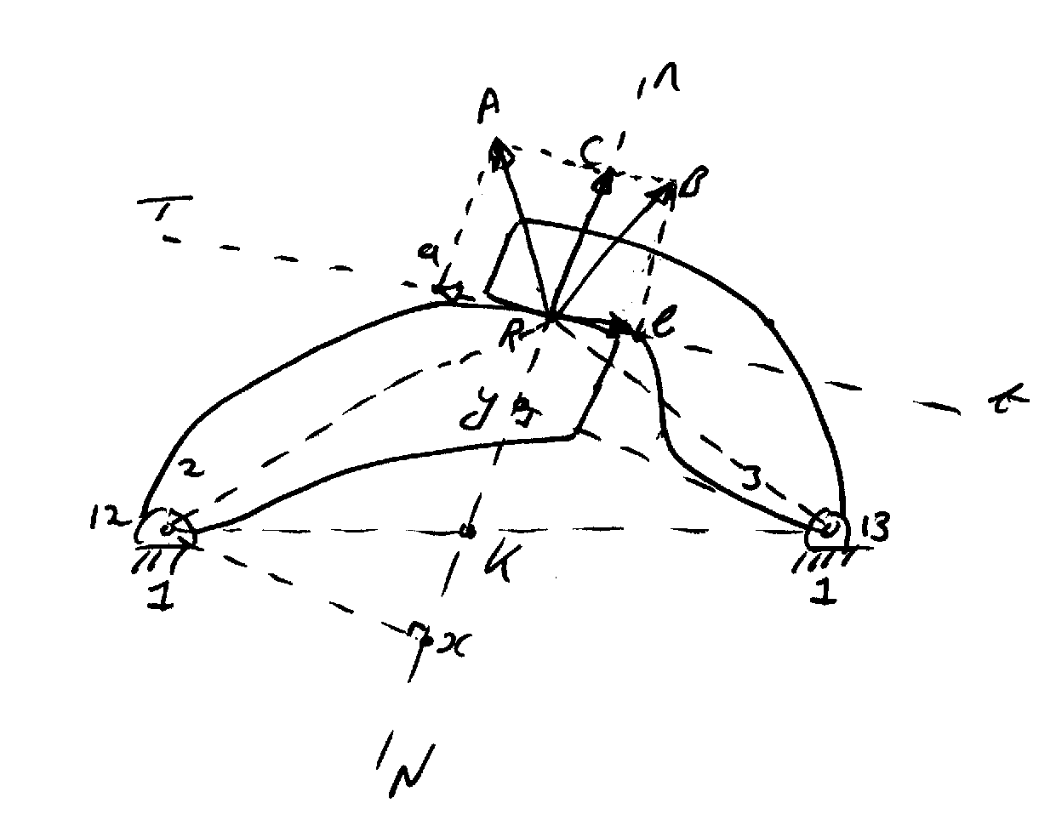

Motion of point R on link 2 is the vector RA and is the vector RB on link 3. These vectors are obviously at 90 degrees to line R-13 and R-12 as these are their respective axes of rotation. (The centres of rotation of link 2 is the point 12 and the centre of rotation of link 3 is the point 13). In order to find an angular velocity ratio we need to break down the velocity vectors RA and RB into their constituent parts along the common normal and the common tangent.

Nn = Common Normal /Line of transmission/Line of Action.

Tt = Common Tangent.

RA = vector representing the velocity of point R on link 2
Its made up of two components RA = Ra + Rc
The directions of RA and RB are known as the point R rotates about centres 12 and 13 respectively.

RB = vector representing the velocity of point R on link 3
Its made up of two components RB = Rb + Rc

Rc is the common vector component representing the motion of points R on both links 2 and 3.

Now V = Rω – where V is the magnitude of RA or RB depending on whether it is the driver or follower being considered.

Ra added to Rb gives the velocity with which the two surfaces slide over each other. In a different mechanism if Ra and Rb were to coincide in direction then these vectors would be subtracted to give the velocity of sliding. Velocity of sliding is important as it will determine wear and lubrication effects. Looking at the diagram again it can be seen that if the point of contact R were to lie on the line of centres 12-13 there would be no sliding – this would then be a pure rolling contact as RA and RB would be equal in magnitude and direction.

V = Rω = Linear velocity

ω₂ ₌ RA and ω₃ ₌ RB
12-R 13-R

ω₃ ₌ RB _{x} 12-R
ω₂ 13-R RA

DIAGRAM 26
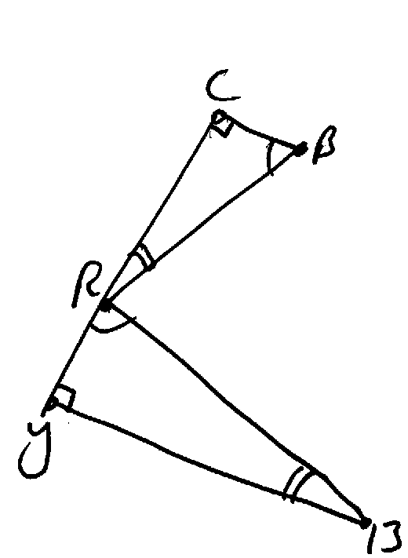

From similar triangles

RB ₌ RC
13-R 13-y

Also RA ₌ RC
12-R 12-x which gives

ω₃ ₌ 12-x
ω₂ 13-y from similar triangles this gives

ω₃ ₌ 12-K
ω₂ 13-K

In conclusion for a pair of curved surfaces in direct contact the angular velocity ratio is inversely proportional to the segments into which the line of centres is cut by the line of transmission. For constant angular velocity ratio the line of transmission must intersect the line of centres at a fixed point. A gear tooth surface has this characteristic – no matter where two gear teeth contact each other the line of transmission remains constant.

LINKED MECHANISMS

Linked mechanisms such as a crank-slider or four-bar linkage are difficult to analyse if a common normal is being sought. An analysis very similar to that carried out in the case of the direct contact mechanism can be carried out. This uses a very similar method to previously to find the vector describing the velocity at the end of each crank. This is resolved into components acting along and perpendicular to the connecting link. The angular velocity ratio between the input and output links can then be resolved using V = Rω as before and similar triangles. The fact that components parallel to the connecting rod cancel out simplifies matters – con-rod length does not change so that velocity components parallel to it cancel each other out.

DIAGRAM 27
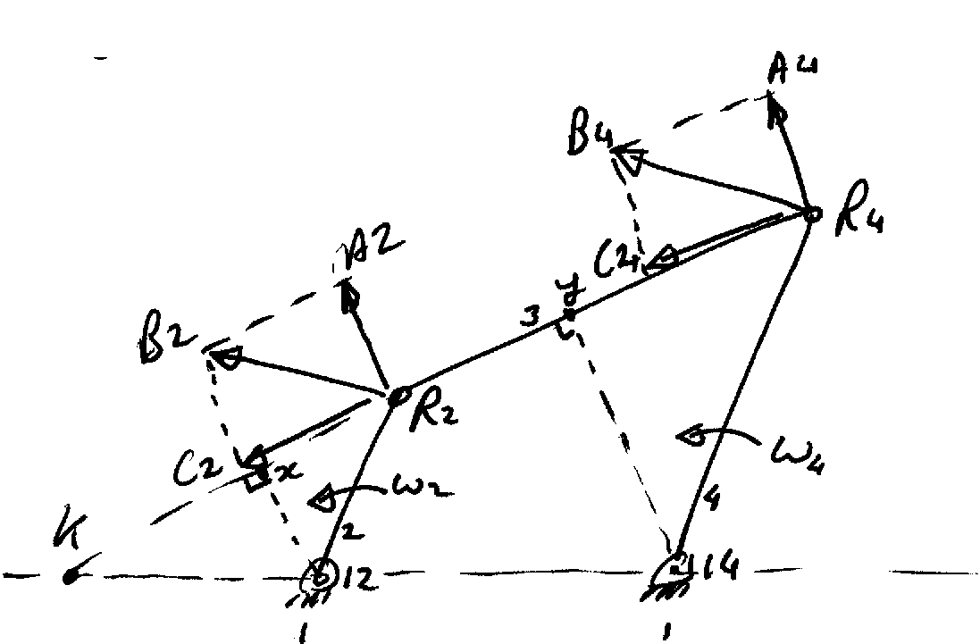

V = Rω = Linear velocity

ω₂ ₌ R ₂B₂ and ω₄ ₌ R ₄B₄
12-R₂ 14-R

ω₂ ₌ R ₂B ₂ x 14-R ₄
ω₄ 12-R₂ R₄B₄

Now 12-R₂ = 12-x and 14 – R₄ = 14 -y
R₂B₂ R₂C₂ R₄B₄ R₄C₄

This gives

ω₂ ₌ R ₂C ₂ x 14-y
ω₄ 12-x R₄C₄

and R2C2 = R4C4 as con-rod does not compress

From similar triangles

ω₂ ₌ K - 14
ω₄ K - 12

TRANSMISSION OF ROTATIONAL MOTION.

Introduction
The transmission of rotational motion from one element or shaft in a machine to another is a universal requirement. If we look at sources of power they are nearly all supplying it in a rotational form, AC or DC motors, IC engines (diesel, petrol), control equipment (stepper motors, rotary pneumatic actuators etc.) That power is supplied via an output shaft and typically in design a rotational speed and torque requirement is specified when ordering a motor. The output shaft of the motor must then be connected to the input shaft of the machine utilising the power. If the two shafts are permanently in line, the ends are said to be “abutting”. In this case normally some form of rigid or flexible coupling is used. Both couplings allow the rotational motion and torque be transmitted from one shaft to another but a flexible coupling is used where there is some minor misalignment or vibration which must be taken into account.

In some cases large and varying angular misalignments occur between two shafts but the hsafts will still intersect at some point, for example in a front-wheel drive motor car power must be transmitted to the front wheels regardless of what angle to the car they are at ( as the vehicle drives around a corner for instance). When shaft axes intersect at a large angle, a device called a Hooke, or Cardan joint may be used. This type of coupling allows rotational motion be transmitted from one shaft to another but unfortunately it introduces a cyclical variation in the angular velocity ratio between the two shafts. By this is meant that for a constant input angular velocity ω a varying or non-constant output is obtained. This makes for a major problem as typically we want a constant speed in and constant speed out - there are joints available which make this possible.

If the shafts to be joined together are not even approximately collinear (or intersecting) they can be connected using belt-drives and chain drives. Gears and friction drives may also be used in some cases.

PARALLED BUT MISALIGNED SHAFTS: THE OLDHAM COUPLING.
Where the shafts to be joined together are parallel but not aligned this simple coupling may be used.
Both shafts in the coupling have a circular flange attached, see Fig. Into this flange a single diametral grove is cut. Between these flanges a disk is inserted which has tongues which protrude from either side and which fit the grooves cut in the flanges. These tongues are at right angles to each other so that on assembly the grooves in each plate are also position at right angles. Obviously as long as the disk remains in place between the two flanges the groves must remain at 90 degrees to each other. There is no relative rotation possible between the flanges and the disk so that the coupling transmits a constant velocity ratio.

Diagram 22

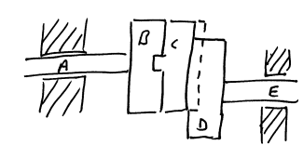

As the shafts rotate the centre of the disk moves in a circular path whose diameter is equal to the distance between the shaft axes. The velocity of sliding in each groove is the product of the angular velocity of the joint and the radius of this circle. Velocities are sinusoidal in that as the disk approaches the edge of the flange it slows down, stops and reverses its direction of sliding
Major disadvantages of this system are the following
- The disk is unbalanced and its eccentric motion will cause the shafts to vibrate
- The sliding surfaces are awkward to lubricate.
- Friction losses are high
- Heating and other effects may be a problem

HOOKE OR CARDAN JOINT
Transmission of rotational motion between shafts which are not collinear but whose axes intersect can be done using a Hooke or Cardan Joint – also known as a universal joint. This joint is used in industry and by the automotive field.

The joint consists of two yokes joined together in the manner shown by a cross shaped piece of metal which is pinned into both yokes and is free to rotate on these pins.

Dig 23

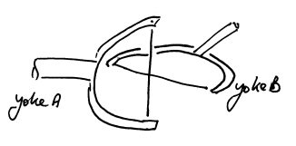

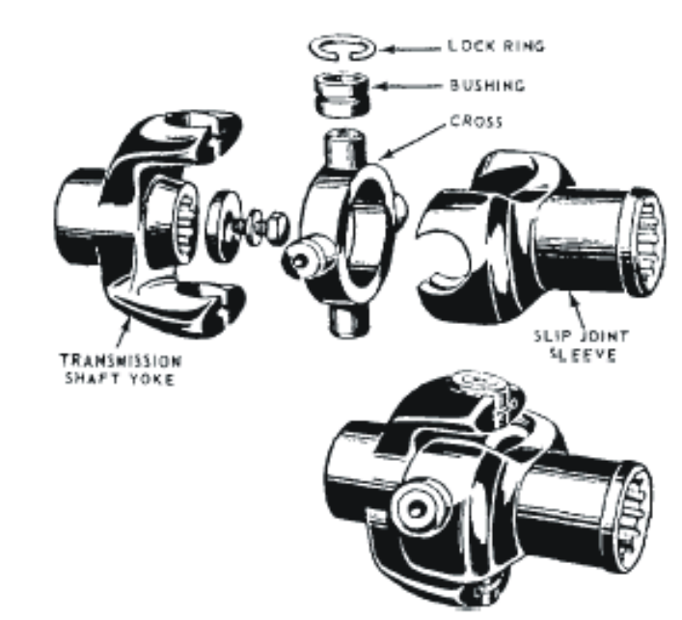
For a constant angular velocity input, ω₃, the output, ω₂, will vary in a complex manner and this is the major problem with the joint. If the angle between the two shafts is given by α and the angle of rotation of the shafts is given β then the equation for angular velocity variation is as follows:

ω₂ ₌ cos α
ω₃ ₁ – sin² β sin² α
For a given and set angle between the two shafts it can be seen that there is a cyclical variation in the input to output velocity ratio. Maximum values occur when sin β = 1, ie. when β = 90⁰ and 270⁰. The denominator is greatest when β = 0, 180⁰ and this condition gives the minimum ratio of the velocities. The difference between these maximum and minimum values can be expressed as a percentage and plotted as a speed fluctuation versus shaft angle as below.

Diagram 24
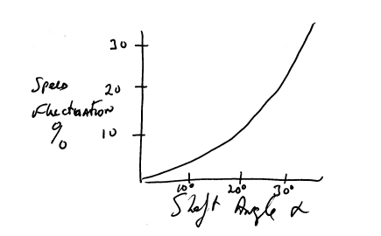
Go to this URL to see an animation of a universal joint running where you can clearly see that it is not a constant velocity joint - http://members.dencity.com/jmh/Photo_archive/Animations/universa.htm

CONSTANT VELOCITY UNIVERSAL JOINT

As stated previously many cases exist in which drives have to be taken through significant and varying angles where any variation in angular velocity is not tolerable - the example taken previously was front wheel drive cars where the front wheels must steer and must be able to move up and down in the suspension. As shown the Hooke joint has a cyclical variation as the shafts rotate. A very common solution is to take two Hooke joints and place them back-to-back (a double Hooke joint). By placing the two joints back to back but 90 degrees out of phase the variations cancel each other out – a decrease in angular velocity at one joint is matched by an equal and opposite increase at its partner joint.

Another simple solution to a constant velocity joint is given below. Essentially both shafts are bent to an equal angle and a sliding pin joint holds them in contact as they rotate. The pin rotates in one plane only, what is known as the homokinetic plane, and moves toward and away from both shaft axes simultaneously. Since the radius of rotation R_{A} and R_{B} are always equal the shafts have equal ω’s. It’s principle of operation is common to virtually all constant velocity universal joints. In that contact is always maintained in the homokinetic plane

DIAGRAM. 28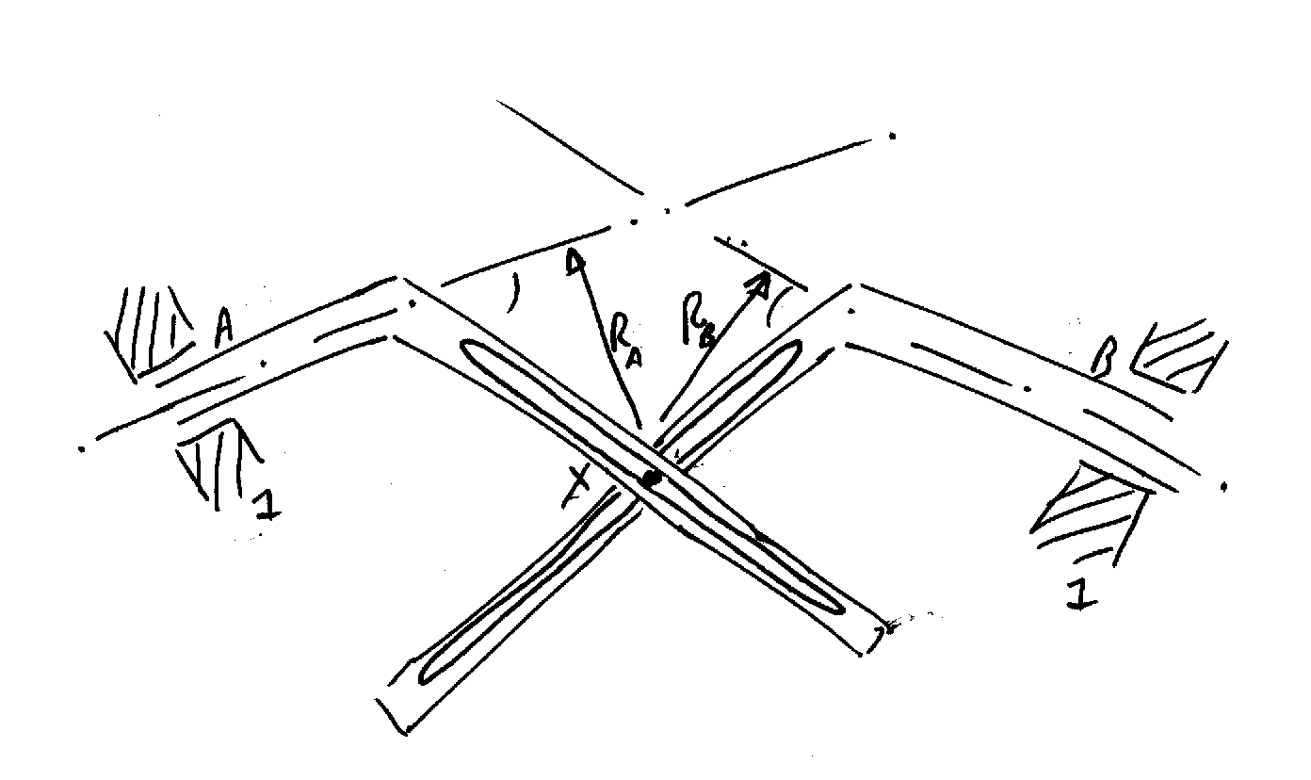

BENDIX WEISS JOINT

A race is a groove or hollow where a ball bearing (small steel sphere) can move. For example a ball bearing will have an inner and outer with the balls contained in both grooves. The assembly of inner race, balls and outer race is done using temperature variations in all components to induce shrinkage and expansion and make assembly easier. A ball bearing will also have a cage which keeps the balls separate and stops them bumping off each other and increasing wear and frictional losses. A similar race is found in the Bendix-Weiss joint. Motion is transmitted from one shaft to another through four or more steel balls that fit between races in the yokes of the shafts. The races are designed so that the centre of each ball lies in the homokinetic plane at all times. The joint gives constant angular velocity ratio. The balls are able to move back and forth in the races allowing end motion without a sliding spline connection – a fifth ball (see figure in handout material) lies at the intersection of the shaft axes for carrying end thrust.

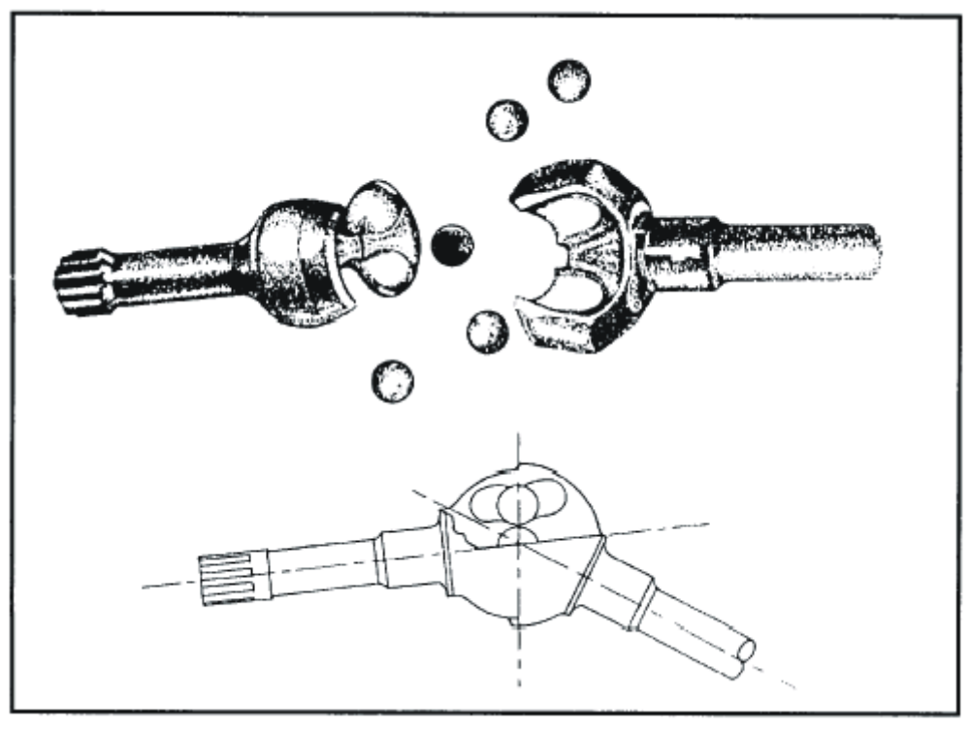INTERMITTENT MOTION MECHANISMS

These are mechanisms which convert continuous motion into intermittent motion, - e.g on a grinding or cutting machine for indexing a shaft. Indexing means rotating through specified angle in this context but could also mean a step. The Geneva Wheel is one such mechanism – it converts continuous revolution into stepped or discontinuous rotational motion. For each revolution of the crank the wheel rotates a fractional part of a revolution, the amount of which depends on the number of slots in the wheel. Typical wheels have from 4 – 12 slots.

An animation of a Geneva wheel in action can be seen at the following URL http://www.cabaret.co.uk/education/geneva.htm or at http://www.brockeng.com/mechanism/Geneva.htm

DIAGRAM 29 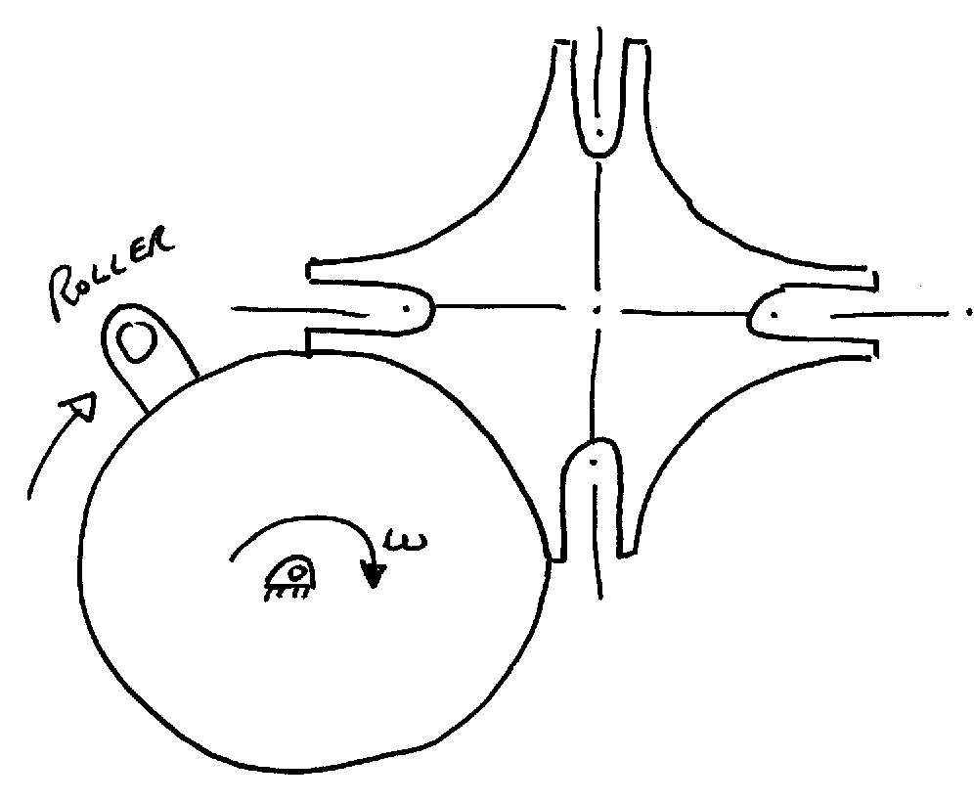
Another intermittent motion mechanism is the ratchet. A common example of a ratchet mechanism is the freewheel mechanism in the rear hub of a bicycle. It makes a clicking sound as the pawl runs over the ratchet

Diagram 30 

